
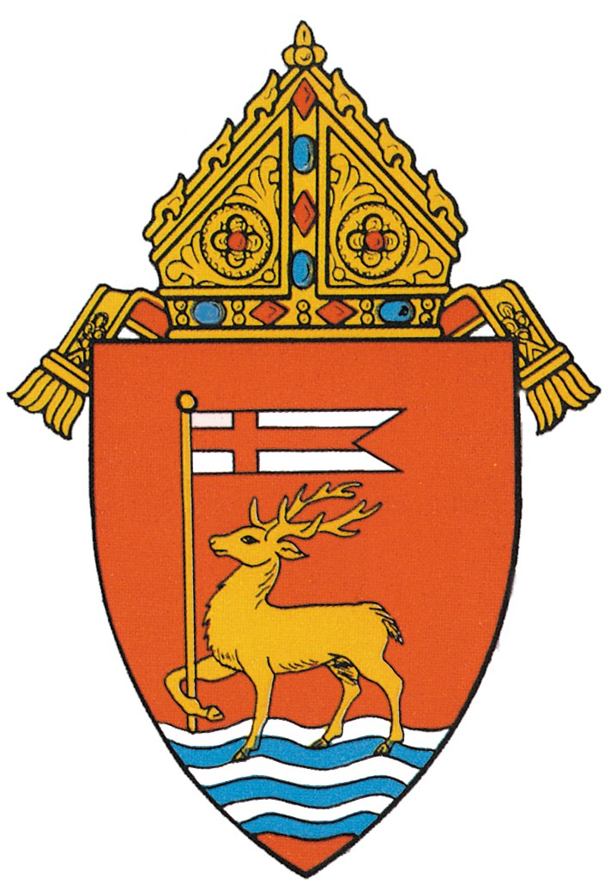
Archdiocese of Hartford
Office of Safe Environment
467 Bloomfield Ave.
Bloomfield, CT 06002

HOW TO REPORT AN INCIDENT OF SEXUAL ABUSE
TO THE ARCHDIOCESE OF HARTFORD

If you have knowledge or suspect that a minor or vulnerable adult (an adult with an intellectual disability) has been sexually abused, in any manner, by personnel of the Archdiocese of Hartford, you are urged to report this information to:

Kathleen D. Nowosadko
Victim Assistance Coordinator
860-541-6475
kathleen.nowosadko@aohct.org

In addition, you will be asked to follow up in writing with a detailed description of the facts involved in the incident. Specifics of this written report can be found in the Policies and Procedures of the Archdiocese of Hartford Relating to Allegations of Sexual Misconduct Involving Minors and Vulnerable Adults. This document is also available online at www.archdioceseofhartford.org. The Archdiocese of Hartford will report any and all incidents to the proper civil authorities.

Mandated reporters in the State of Connecticut are required by law to report any incident of sexual abuse involving a minor or vulnerable adult. We encourage any Non-Mandated persons to report such incidents to the proper authorities as well. We support your right to do so.

Incidents involving sexual abuse of minors (persons under the age of 18) should be reported to:
State Department of Children and Families Care-line
1-800-842-2288

Incidents involving sexual abuse of vulnerable adults aged 18 – 59 should be reported to the:
Connecticut Department of Developmental Services – AID Division
for Persons with Intellectual Disabilities
1-844-878-8923

Incidents involving sexual abuse of vulnerable adults aged 60 and over should be reported to:
Department of Social Services for the Elderly
1-888-385-4225

Once a written report of an incident of sexual abuse of a minor or vulnerable adult has been received, an investigation will be undertaken by, or on behalf of, the Archdiocese of Hartford.

