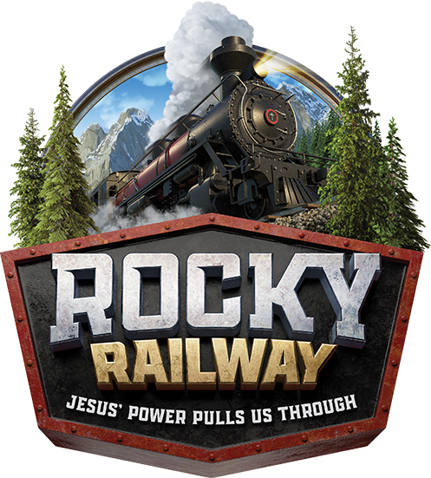
ST. JUNIPERO SERRA SUMMER BIBLE CAMP
July 11 – 15, 2022
9:00 AM – 12 NOON (AGES 5 – 10)
$25 PER CHILD/$40 PER TWO/$55–THREE OR MORE
Snacks, Activities, Music, Movies, Games
CHILD’S NAME: ________________________ NICKNAME: ____________________ AGE: ______________ DATE OF BIRTH: _____________________ Gender______ shirt size YS_ YM_ YL_ ; AS_ AM _ AL_
CHILD’S NAME: ________________________ NICKNAME: ____________________ AGE: ______________ DATE OF BIRTH: _____________________ Gender______ shirt size YS_ YM_ YL_ ; AS_ AM _ AL_
CHILD’S NAME: ________________________ NICKNAME: ____________________ AGE: ______________ DATE OF BIRTH: _____________________ Gender______ shirt size YS_ YM_ YL_ ; AS_ AM _ AL_
ALLERGIES/HEALTHPROBLEMS/CONCERNS: __________________________________________________________________________________________
Parent Information: Marital Status: Single ___ Married ___ Divorced ___ Remarried ___
Father’s Address: Street_____________________________________ Town ____________________
Home Phone __________________________ Cell Phone ___________________________
Mother’s Address: Please check if same as above address ____
Street_____________________________________ Town__________________________
Home Phone __________________________ Cell Phone __________________________
E-Mail Address: ________________________________________________________________________
Emergency Contact: Name________________________________ Phone # ______________________
Relationship to Student_____________________________________________________
I give permission for my child(ren) to be photographed by the Faith Formation office of St. Junipero Serra Parish. I understand that these photographs may be posted on the St. Junipero Serra Parish social media. Yes____ No_____
*Parent Signature: _________________________________________________
Your child/children/guardianship is eligible to participate in ‘ROCKY RAILWAY - VBS 2022 at St. Francis of Assisi Church. The church, rectory and church grounds will be used for activities. It will take place under the guidance and supervision of employees and volunteers from St. Junipero Serra Parish. A brief description of the program follows: Lessons and activities including Bible stories, snack, sports & games, music and arts and crafts. As parent or legal guardian, you remain fully responsible for any legal responsibility which may result from any personal actions taken by the named student/students. I hereby consent to participation by my child/children in the ‘ROCK RAILWAY - VBS 2022’ described above.
I hereby authorize the adults in charge to take my child/children for medical treatment in the event of an emergency in which neither parent can be reached. I authorize any licensed physician or medical center to treat my children.
*Parent Signature ________________________________________ Date_______________________

