St. Junipero Serra Parish - Office of Faith Formation
80 Hayes Rd., South Windsor, CT 06074
www.saintjuniperoserra.org
phone: 860-644-2549 email: faithformation@southwindsor.cc
2022-2023 Whole Parish Catechesis Family Registration for Grades K – 6
*Please print clearly. It is important that you tell us of any changes in your address, email, or phone.

_______________________________________ _____________________________________
Family \ Household Last Name Child(ren) Last name if different

_____________________________ _________________ __________________ ____________________________
Father's first name Religion Cell # Email address (please print clearly)

_______________ ___________ _________________ __________________ ____________________________
Mother’s MAIDEN First name Religion Cell # Email address (please print clearly)
______________________________ _______________________ _____________ ________________________
Mailing address Street/PO Box City Zip Home Phone

Parent Information: Marital Status: Single ___ Married ___ Divorced ___ Remarried ___ Widowed ___

Emergency Contact ________________________________ _____________ ______________________________
Name Relation Phone
Child 1:
____________________________________ ______ _______ ______ ________________________________________
First Name M/F DOB: Grade Allergy (you are welcome to bring own food)

Child 2:
____________________________________ ______ _______ ______ ________________________________________
First Name M/F DOB: Grade Allergy (you are welcome to bring own food)

Child 3:
____________________________________ ______ _______ ______ ________________________________________
First Name M/F DOB: Grade Allergy (you are welcome to bring own food)

Child 4:
____________________________________ ______ _______ ______ ________________________________________
First Name M/F DOB: Grade Allergy (you are welcome to bring own food)
If your child is making a Sacrament this year, please list your child’s name and Sacrament.
* First Reconciliation (Gr. 2); *First Eucharist (Gr. 3)
Child 1: _______________________________ ________________________________ ________________________
Name Sacrament City, State of birth
Child 2: _______________________________ ________________________________ ________________________
Name Sacrament City, State of birth
Child 3: _______________________________ ________________________________ ________________________
Name Sacrament City, State of birth
Child 4: _______________________________ ________________________________ ________________________
Name Sacrament City, State of birth

Baptismal Certificates are required of new students and must be submitted with registration.
*Please indicate your child’s place of Baptism below
St. Francis of Assisi _____or St. Margaret Mary_____ (we should have these certificates on file)
Other Parish__________________________________________________________________
WPC - Gr K-6, Registration fee, if you attend our Registration Night on June 13, 2022
- $65 (for a family with one child) - $85 (for a family with two or more children)
WPC - Gr K-6, Registration fee, if you do not attend our Registration Night on June 13, 2022
- $75 (for a family with one child) - $95 (for a family with two or more children)
Sacramental fee, children making their primary sacraments will pay an additional $20 for materials provided during their four sacramental workshops which will be held during the year. The primary sacramental program is a two-year program. - $20 First Reconciliation (usually Gr. 2 or 3) - $20 First Eucharist (usually Gr. 3 or 4)
Please indicate your Class Choice
___ Sat, class A will begin with the 4P.M. Mass - until 6:30pm; (class dates: 9/17, 10/8, 11/5, 1/21, 3/11)
___ Sun, class B will begin with the 11A.M. Mass – until 1:30pm; (class dates: 9/18, 10/9, 11/6, 1/22, 3/12)
___ Sun, class C will begin with the 11a.m. Mass – until 1:30pm; (class dates:9/25,10/16,11/13,1/29, 3/19)

IMPORTANT PERMISSIONS
Photo Permission: I give permission for my child(ren) to be photographed by St. Junipero Serra Parish and I understand that the photos may be used to publicize parish activities. They may appear on the parish website and other parish social media. Names of individuals will not be posted alongside photos.
Yes, I give permission for my child to be photographed ______________
No, I do NOT give permission for my child to be photographed _____________ _
The Child Lures Prevention Program ‘Think First & Stay Safe’ Permission
As required by the Archdiocese of Hartford, to be presented every year, will be presented to all families at one of our scheduled sessions. Please verify by initiating the statements below.
___ I acknowledge the Safe Environment Program is being offered during 2022-2023 Whole Parish Catechesis.
___ my child has permission to participate in the safe Environment program class
___ It is my choice that our family NOT participate in the Safe Environment program. (This means you are opting out and your child will not attend the Child Lures program)
* If you have chosen to opt out of the program, please fill out the OPT out FORM - materials from the parish will be provided to you to use to instruct your child(ren) on the topic.
Name of Parent or Guardian (please print clearly) ____________________________________________
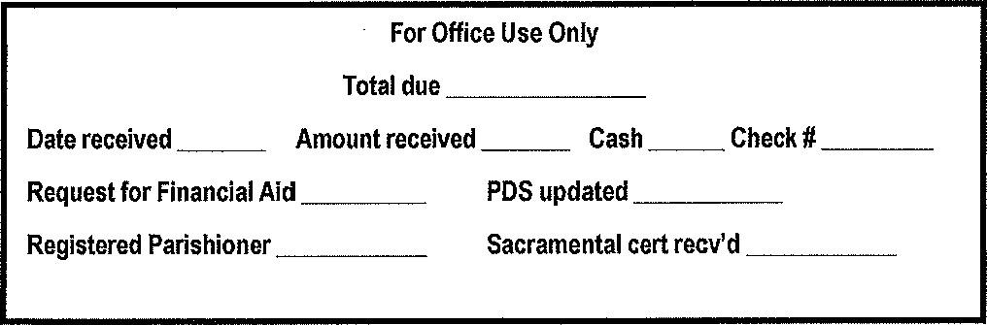
Signature ______________________________________________________ Date ____________________

